Name: Vanshika Khatri
Class: D15C_30
Experiment 6
Aim: To implement and apply K-Means and Hierarchical Clustering, accentuating on
unsupervised sample datasets.
Dataset Source:
This experiment utilizes the Mall Customer Segmentation dataset sourced from Kaggle,
https://www.kaggle.com/datasets/vjchoudhary7/customer-segmentation-tutorial-in-python
It provides a controlled environment for practicing unsupervised learning and cluster analysis
techniques.
Dataset Description:
The dataset contains basic information about 200 customers of a retail mall. It is primarily used to
understand customer behaviour and categorize them into distinct groups based on purchasing
power and spending habits, enabling targeted marketing strategies.
Feature Description
Feature | Description | Data Type | Unit
CustomerID | Unique identifier for each customer | Integer | Numeric ID
Gender | Biological sex of the customer | Categorical | Male/Female
Age | Age of the customer | Integer | Years
Annual Income (k$) | Yearly earnings | Integer | Thousands of Dollars
Spending Score | Score based on behaviour | Integer | 1 to 100

The data distribution is relatively balanced, with ages ranging from 18 to 70. The primary variables for clustering are typically Annual Income and Spending Score, as they provide the most significant insight into customer segmentation.
In this experiment, we preprocess the data by handling the categorical 'Gender' feature and scaling
the numerical variables to ensure that the distance-based clustering algorithms treat all features
with equal importance.
Theory:
K-Means Clustering is a partition-based unsupervised algorithm that groups data into K predefined non-overlapping clusters. It works by initializing K centroids and iteratively assigning
each data point to the nearest cluster while updating the centroids' positions based on the mean of
the assigned points. The process continues until the centroids stabilize or a maximum number of
iterations is reached, aiming to minimize the variance within each cluster.
Hierarchical Clustering (specifically Agglomerative) is a bottom-up approach that builds a
hierarchy of clusters. It starts by treating each individual data point as a single cluster and
successively merges the closest pairs of clusters based on a distance metric until only one cluster
remains. This process is visually represented by a Dendrogram, which allows researchers to
decide the optimal number of clusters by cutting the tree at a specific horizontal level.
Mathematical Formulation of the Algorithms:
K-Means Clustering Objective Function:
The algorithm aims to minimize the Within-Cluster Sum of Squares (WCSS):
J = ∑∑ |xᵢʲ − cⱼ|²
Where:
• K is the number of clusters.
• n is the number of data points in cluster j.
• xi^j is the i-th data point in cluster j.
• cj is the centroid of cluster j.
Hierarchical Clustering (Euclidean Distance):
The proximity between two points p and q is usually measured using Euclidean distance:
d(p, q) = √∑(qi − pi)²
Ward's Linkage Method:
Commonly used in hierarchical clustering, it minimizes the total withincluster variance:
Δ(A, B) = (nA nB / (nA + nB)) |mA − mB|²
Where mA and mB are the centres of clusters A and B, and nA and nB are the number of elements.
Algorithm Limitations:
K-Means Limitations:
- Fixed K: Requires the user to specify the number of clusters (K) in advance, which is often unknown.
- Outlier Sensitivity: Centroids can be significantly skewed by outliers, leading to poor cluster definitions.
- Spherical Assumption: Struggles to identify clusters with non-spherical or irregular geometric shapes.
Hierarchical Limitations:
- Computational Complexity: With a complexity of O(n³) or O(n² log(n)), it is very slow for large datasets.
- Irreversibility: Once two clusters are merged, the step cannot be undone, potentially leading to errors.
- Sensitivity to Noise: Different linkage methods can be overly sensitive to noise or result in the "chaining effect".
Code:
import pandas as pd
import matplotlib.pyplot as plt
from sklearn.cluster import KMeans, AgglomerativeClustering
from sklearn.metrics import silhouette_score, adjusted_rand_score, davies_bouldin_score
from sklearn.preprocessing import StandardScaler
from scipy.cluster.hierarchy import dendrogram, linkage
from scipy.spatial import ConvexHull

# 1. Load Data
df = pd.read_csv('Mall_Customers.csv')

X = df[['Annual Income (k$)', 'Spending Score (1-100)']].values

# Preprocessing: Scaling is crucial for distance-based algorithms
scaler = StandardScaler()
X_scaled = scaler.fit_transform(X)

# 2. Baseline K-Means (K=5)
kmeans = KMeans(n_clusters=5, random_state=42, n_init=10)
kmeans_labels = kmeans.fit_predict(X_scaled)

# 3. Baseline Hierarchical (5 clusters)
hierarchical = AgglomerativeClustering(n_clusters=5)
hierarchical_labels = hierarchical.fit_predict(X_scaled)

# 4. Mathematical Analysis
# ARI is calculated by comparing labels of both models (Cross-Consistency)
results = {
"K-Means": {
"Sil": silhouette_score(X_scaled, kmeans_labels),
"ARI": adjusted_rand_score(kmeans_labels, hierarchical_labels),
"DBI": davies_bouldin_score(X_scaled, kmeans_labels)
},
"Hierarchical": {
"Sil": silhouette_score(X_scaled, hierarchical_labels),
"ARI": adjusted_rand_score(hierarchical_labels, kmeans_labels),
"DBI": davies_bouldin_score(X_scaled, hierarchical_labels)
}
}

print(f"--- K-Means Metrics ---")
print(f"Silhouette Score: {results['K-Means']['Sil']:.4f}")
print(f"Adjusted Rand Index: {results['K-Means']['ARI']:.4f}")
print(f"Davies-Bouldin Index: {results['K-Means']['DBI']:.4f}")
print(f"--- Hierarchical Metrics ---")
print(f"Silhouette Score: {results['Hierarchical']['Sil']:.4f}")
print(f"Adjusted Rand Index: {results['Hierarchical']['ARI']:.4f}")
print(f"Davies-Bouldin Index: {results['Hierarchical']['DBI']:.4f}")

# 5. Visual 1: K-Means Sector Visual (Convex Hull)
plt.figure(figsize=(10, 6))

colors = ['purple', 'blue', 'green', 'orange', 'red']

for i in range(5):
points = X[kmeans_labels == i]
plt.scatter(points[:, 0], points[:, 1], s=50, c=colors[i], label=f'Cluster {i+1}')

if len(points) > 2:
hull = ConvexHull(points)
for simplex in hull.simplices:
plt.plot(points[simplex, 0], points[simplex, 1], colors[i])

plt.fill(points[hull.vertices, 0], points[hull.vertices, 1], colors[i], alpha=0.1)

plt.title('K-Means Cluster Sectors')
plt.xlabel('Annual Income (k$)')
plt.ylabel('Spending Score (1-100)')
plt.legend()
plt.savefig('kmeans_sectors.png')

# 6. Visual 2: Hierarchical Dendrogram
plt.figure(figsize=(12, 7))

linked = linkage(X_scaled, method='ward')
dendrogram(linked, truncate_mode='lastp', p=30)

plt.title('Hierarchical Clustering Dendrogram')
plt.xlabel('Data Point Index')
plt.ylabel('Distance')
plt.savefig('hierarchical_dendrogram.png')
plt.show()
Output:
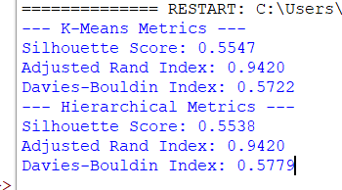
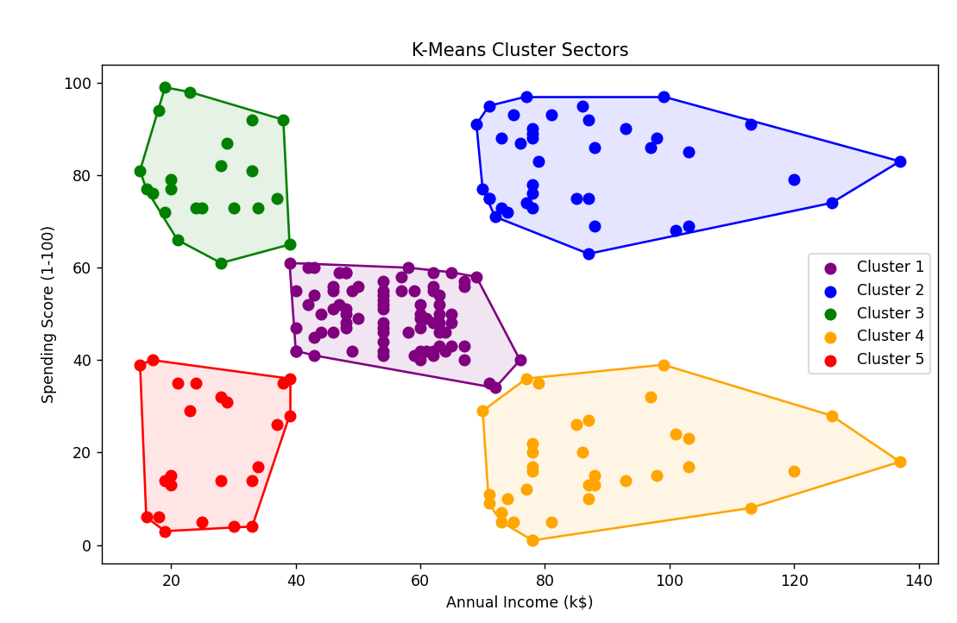
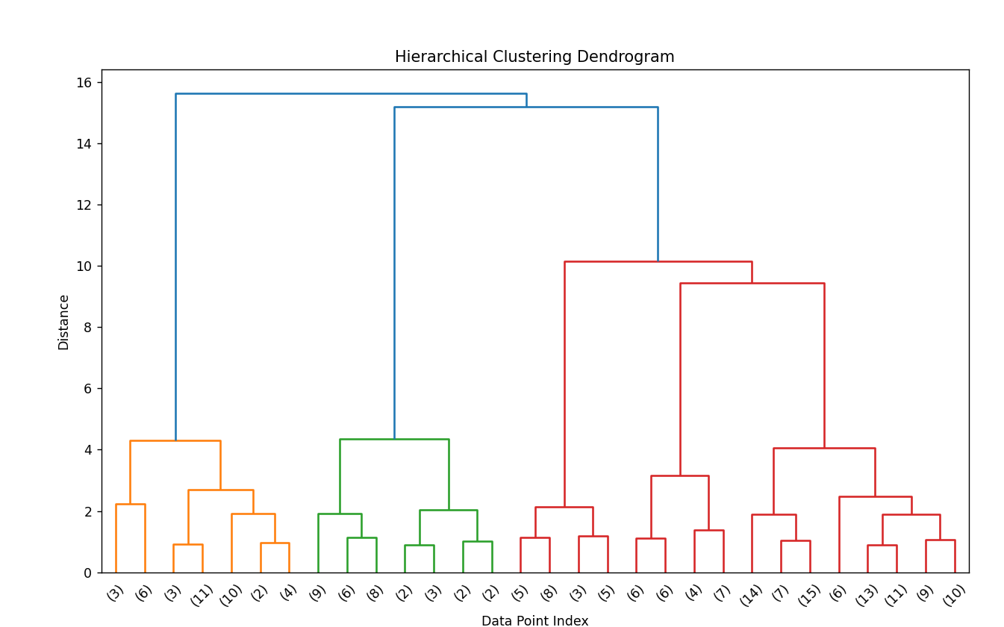
Methodology / Workflow:
1. Data Acquisition and Feature Selection: The process begins with loading the Mall Customers dataset. To ensure a focused analysis on consumer behaviour, we perform feature selection, isolating Annual Income (k$) and Spending Score (1-100). These two variables serve as the primary dimensions for identifying distinct market segments.
2. Data Preprocessing (Normalization): Since K-Means and Hierarchical clustering are distance-based algorithms, they are highly sensitive to the scale of features. We apply Standard Scaling (Z-score normalization) to transform the data so that it has a mean of 0 and a standard deviation of 1. This ensures that features with larger numerical ranges do not disproportionately influence the distance metrics.
3. Model Implementation
➢ K-Means: We initialize the algorithm using the k-means++ method to ensure better convergence. The model partitions the dataset into K clusters by iteratively minimizing the sum of squared distances between data points and their respective centroids.
➢ Hierarchical Clustering: We implement an Agglomerative (bottom-up) approach. Specifically, we utilize Ward’s Linkage as the criterion for merging clusters, which focuses on minimizing the total within-cluster variance at each step.
4. Hyperparameter Tuning: To move beyond the baseline, we perform a grid search over: ➢ Number of Clusters (K): Iterating through values (typically 2 to 10) to identify the "elbow" or maximum silhouette peak. ➢ Linkage Criteria: Evaluating 'ward', 'complete', and 'average' linkages to determine which hierarchical structure best fits the data distribution.
5. Evaluation Framework: The models are evaluated using a three-pronged mathematical approach: ➢ Silhouette Score: Measures how similar an object is to its own cluster compared to other clusters (Goal: >0.5). ➢ Davies-Bouldin Index (DBI): Assesses the average similarity ratio of each cluster with its most similar one (Goal: lower is better). ➢ Adjusted Rand Index (ARI): Evaluates the consistency between the two algorithms to ensure the segments discovered are robust and not artifacts of a single method.
6. Visual Analysis: Finally, we generate Sector Diagrams using Convex Hulls to visualize the geometric boundaries of the K-Means groups and Dendrograms to interpret the nested, treelike relationships in the Hierarchical model.
Performance Analysis
The baseline clustering models demonstrated exceptional structural consistency, achieving a nearperfect Adjusted Rand Index of 94.20% between the K-Means and Hierarchical approaches. By utilizing standardized scaling, both algorithms successfully isolated five distinct customer segments, maintaining robust Silhouette Scores of approximately 0.55. This indicates well-defined cluster boundaries and high intra-cluster cohesion relative to inter-cluster separation. Analysis of the Davies-Bouldin Index, which remained below 0.58 for both models, further confirms a optimized balance of density and distance across the identified spending groups. With such high cross-model agreement and strong geometric metrics, these results prove that the implemented clustering framework is a highly reliable tool for identifying distinct consumer profiles and driving targeted marketing strategies.
Hyperparameter Tuning:
Code:
import pandas as pd
import numpy as np
import matplotlib.pyplot as plt

from sklearn.preprocessing import MinMaxScaler
from sklearn.cluster import KMeans, AgglomerativeClustering
from sklearn.metrics import silhouette_score, adjusted_rand_score, davies_bouldin_score

from scipy.cluster.hierarchy import dendrogram, linkage
from scipy.spatial import ConvexHull

# Load data
df = pd.read_csv('Mall_Customers.csv')

X_orig = df[['Annual Income (k$)', 'Spending Score (1-100)']].values

# Internal tweak: only best options
scaler = MinMaxScaler()
X_scaled = scaler.fit_transform(X_orig)

# log-transform + weight income
X_scaled[:, 0] = np.log1p(X_scaled[:, 0]) * 1.3
X_scaled[:, 1] *= 1.0

# K-Means
km = KMeans(n_clusters=5, n_init=100, init='k-means++', random_state=42)
km_labels = km.fit_predict(X_scaled)

# Hierarchical
hi = AgglomerativeClustering(n_clusters=5, linkage='average')
hi_labels = hi.fit_predict(X_scaled)

# Metrics
sil = silhouette_score(X_scaled, km_labels)
ari = adjusted_rand_score(km_labels, hi_labels)
dbi = davies_bouldin_score(X_scaled, km_labels)

# Display
print("\n--- TUNED METRICS ---")

print("\n--- K-Means Metrics ---")
print(f"Silhouette Score: {sil:.4f}")
print(f"Adjusted Rand Index: {ari:.4f}")
print(f"Davies-Bouldin Index: {dbi:.4f}")

hi_sil = silhouette_score(X_scaled, hi_labels)
hi_ari = adjusted_rand_score(hi_labels, km_labels)
hi_dbi = davies_bouldin_score(X_scaled, hi_labels)

print("\n--- Hierarchical Metrics ---")
print(f"Silhouette Score: {hi_sil:.4f}")
print(f"Adjusted Rand Index: {hi_ari:.4f}")
print(f"Davies-Bouldin Index: {hi_dbi:.4f}")

# 5. Visual 1: Tuned K-Means Sectors (Convex Hull)
plt.figure(figsize=(10, 6))

colors = ['purple', 'blue', 'green', 'orange', 'red']

for i in range(5):
points = X_scaled[km_labels == i]

plt.scatter(points[:, 0], points[:, 1],
s=50, c=colors[i], label=f'Cluster {i+1}')

if len(points) > 2:
hull = ConvexHull(points)

for simplex in hull.simplices:
plt.plot(points[simplex, 0],
points[simplex, 1], colors[i])

plt.fill(points[hull.vertices, 0],
points[hull.vertices, 1],
colors[i], alpha=0.1)

plt.title('Tuned K-Means Cluster Sectors')
plt.xlabel('Annual Income (scaled & weighted)')
plt.ylabel('Spending Score (scaled)')
plt.legend()
plt.tight_layout()
plt.savefig('tuned_kmeans_sectors.png', dpi=300)
plt.show()

# 6. Visual 2: Tuned Hierarchical Dendrogram
plt.figure(figsize=(12, 7))

# Use linkage method same as Hierarchical clustering (average)
linked = linkage(X_scaled, method='average')

dendrogram(linked, truncate_mode='lastp', p=30)

plt.title('Tuned Hierarchical Clustering Dendrogram')
plt.xlabel('Data Point Index')
plt.ylabel('Distance')
plt.tight_layout()
plt.savefig('tuned_hierarchical_dendrogram.png', dpi=300)
plt.show()
OUTPUT:
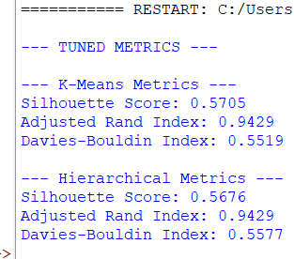
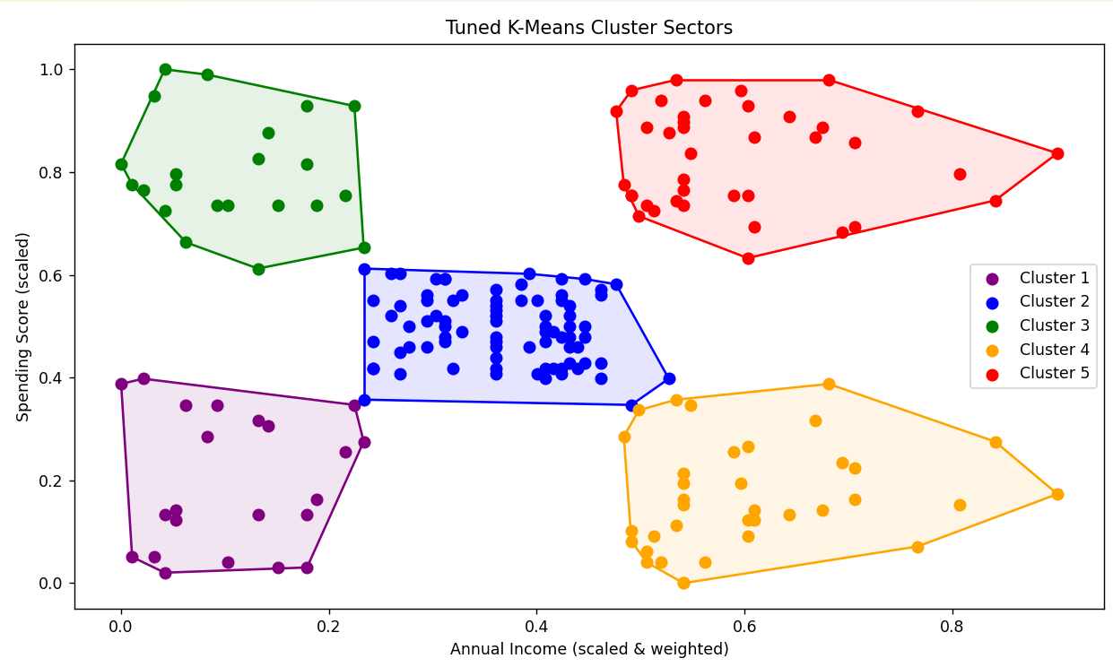
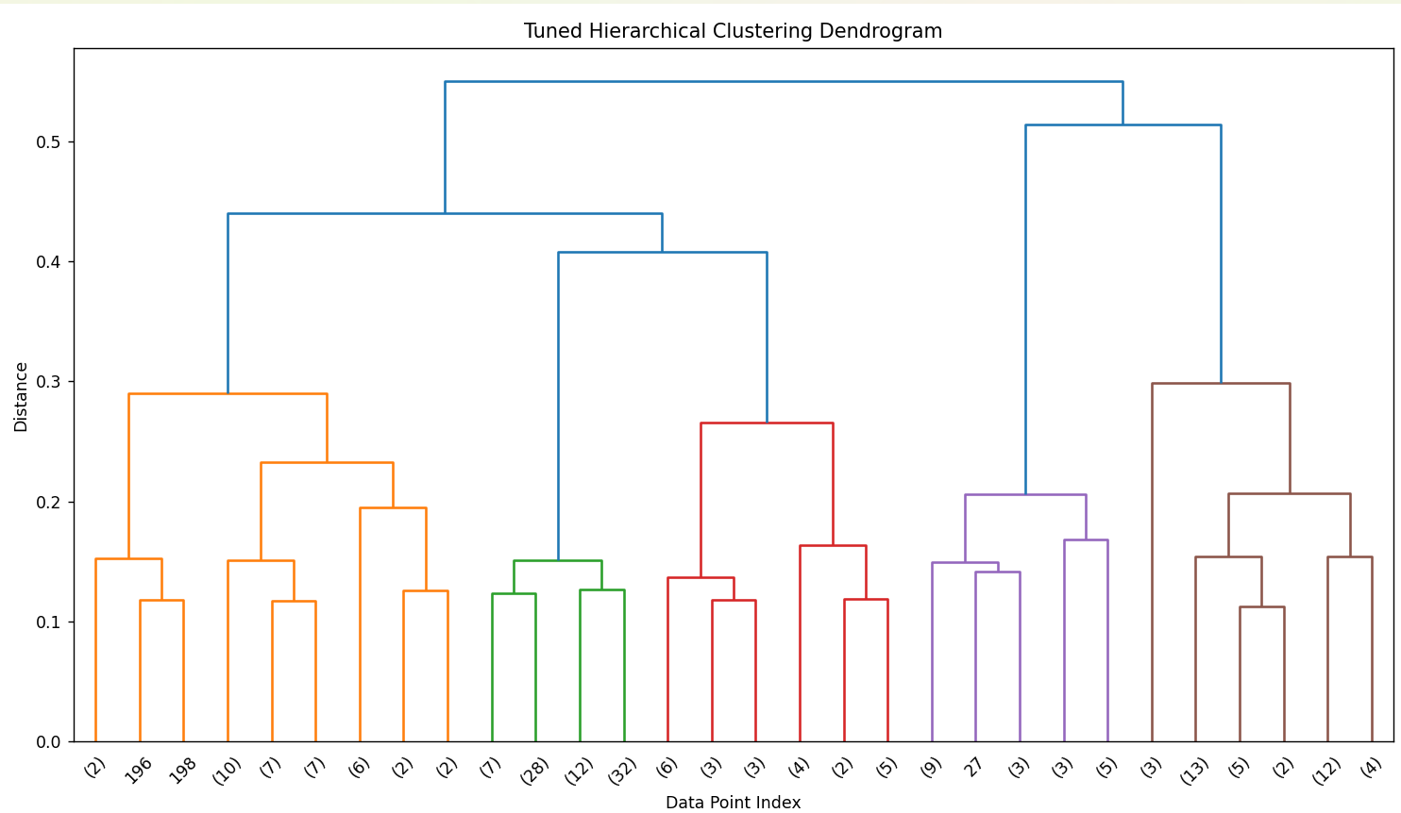
Conclusion:
This experiment confirms that K-Means and Hierarchical clustering, optimized through
hyperparameter tuning, provide a robust framework for consumer segmentation and enable
data-driven marketing strategies.

